
DECLARATION OF MAJOR/MINOR
CCAS Undergraduate Services Office 801 22nd St, NW
Phillips Hall 107
Washington, DC 20052
Phone: (202) 994-6210 Fax: (202) 994-6213 Today’s Date _

Major/Minor approval is granted by designated faculty members in each area of study. To declare a major/minor, visit the department and meet with the relevant individual(s) to fill out this document. Once completed and signed, return this form to the CCAS Undergraduate Services Office (Phillips Hall 107).

Name: GWid:
Last Name First Name M.I.

Daytime Phone: GW E-mail: @gwmail.gwu.edu

Name of Major(s)

Interior Architecture

□ BA □ BS □ BFA
□ Add □ Drop □ Keep

Name of Faculty Advisor
Catherine K Anderson

Concentration (if applicable):

□ BA □ BS

□ BFA

□ Add □ Drop □ Keep
Degree Code
Major Code
Second Major Code
Minor Code
Second Minor or Micro-Minor Code
Office Use Only
Double Degree:
Concentration Code
Concentration Code
Double major
CCAS Approval
Date
Degree Code
Major Code
Double degree
Concentration (if applicable):
If you list two majors, mark one of the below options:
Double major (two majors, one degree, 120 hrs.) □
*Double degree (two majors, two degrees, 150 hrs.) □
*requires separate application

Name of Minor(s) or Micro-Minor Name of Faculty Advisor
□ Add □ Drop □ Keep

□ Add □ Drop □ Keep

To declare a major or minor, the approved Plan of Study must be completed on side 2 of this form.

This Tentative Plan of Study for the major or minor is an informal document. Discuss major or minor requirements with your faculty. Please check all relevant policies, including: (a) minimum of 60 hours at GW; (b) no grade below C- in upper-level courses (some departments require all courses to be a C- or higher); (c) no required coursework for the major or minor may be taken P/NP

Tentative Plan of Study for an Undergraduate Major or Minor
Semester/Yr. | Department & Course Title | GW or Transfer
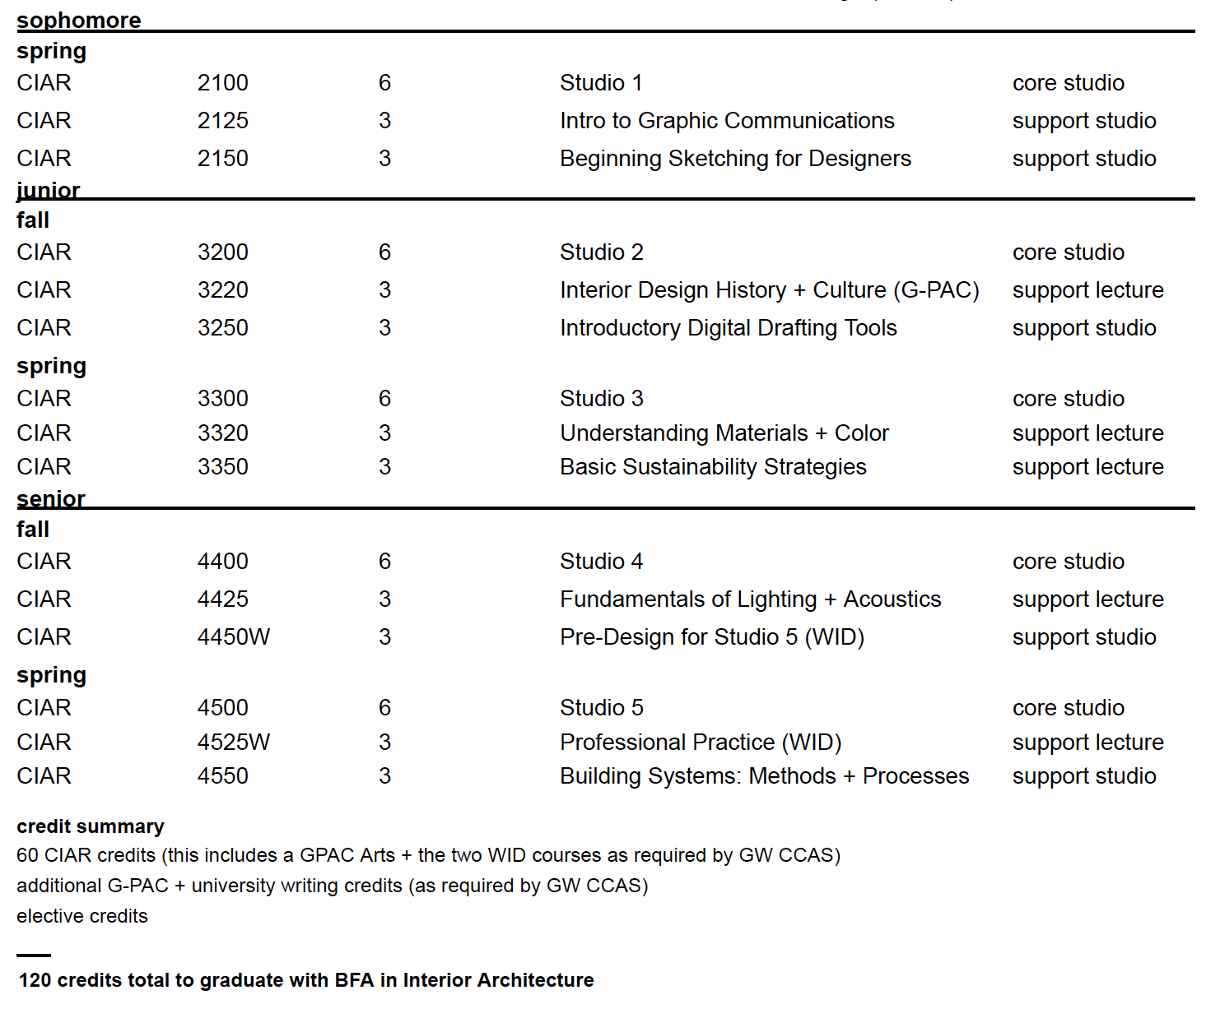
If changes to the requirements in the University Bulletin are allowed but not listed on this form, it is the student’s responsibility to ensure that these changes are communicated by the faculty officially through DegreeMAP.
Departmental Approval(s)
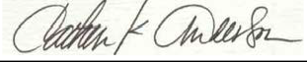
Please note: Certain departments may require a faculty advisor’s approval in addition to that of the department.

Department Approval (1st Major/Minor): |  | Date:
Department Approval (2nd Major/Minor): |  | Date:

I have reviewed the requirements for the major(s) and the minor(s) (where applicable) as stated in the current
University Bulletin and understand what I must do to meet them.

Student Signature: Date:

